**Class:** Final Year (Computer Science and Engineering)

**Year:** 2023-24 **Semester:** 1

**Course:** High Performance Computing Lab

**Practical No. 2**

**Exam Seat No: 2020BTECS00023**

**Name: Sumit Narake**

**Title of practical: Study and implementation of basic OpenMP clauses**

Implement following Programs using OpenMP with C:

1. Vector Scalar Addition
2. Calculation of value of Pi

Analyse the performance of your programs for different number of threads and Data size.

**Problem Statement 1: Vector Scalar Addition**

**Screenshots:**

**Vector Scalar Addition Sequential Code:**

#include <omp.h>

#include <stdio.h>

#include <pthread.h>

void main()

{

    int N = 100;

    int A[N];

    for(int i=0;i<N;i++)A[i] = i + 1;

    int S = 2000;

    double itime, ftime, exec_time;

    itime = omp_get_wtime();

    for (int i = 0; i < N; i++)

    {

        A[i] += S;

        printf("Thread: %d Index: %d\n", omp_get_thread_num(),i);

    }

    ftime = omp_get_wtime();

    exec_time = ftime - itime;

    // for(int i=0;i<N;i++){

    //     printf("%d ", A[i]);

    // }

    printf("\nTime taken is %f\n", exec_time);

    printf("\n");

}

**Vector Scalar Addition Sequential Output:**

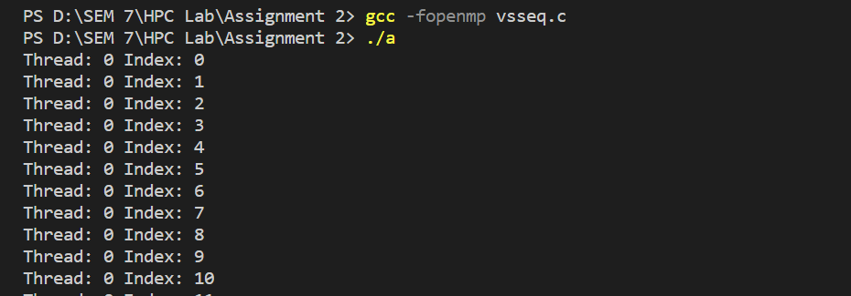

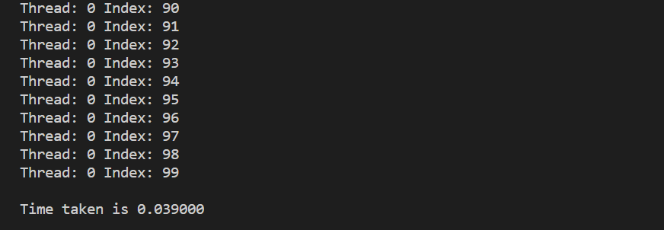

**Vector Scalar Addition Parallel Code:**

#include <omp.h>

#include <stdio.h>

#include <pthread.h>

void main()

{

    int N = 100;

    int A[N];

    for(int i=0;i<N;i++)A[i] = i + 1;

    int S = 212354454;

    omp_set_num_threads(6);

    double itime, ftime, exec_time;

    itime = omp_get_wtime();

    #pragma omp parallel for private(S)

    for (int i = 0; i < N; i++)

    {

        A[i] += S;

        // printf("Thread: %d Index: %d\n", omp_get_thread_num(),i);

    }

    ftime = omp_get_wtime();

    exec_time = ftime - itime;

    // for(int i=0;i<N;i++){

    //     printf("%d ", A[i]);

    // }

    printf("\nTime taken is %f\n", exec_time);

}

**Vector Scalar Addition Parallel Output:**

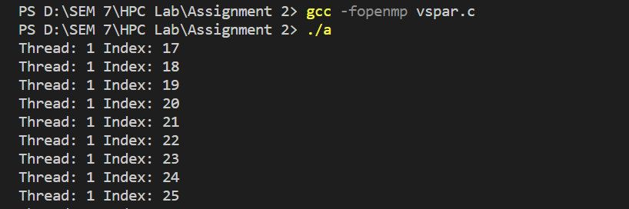

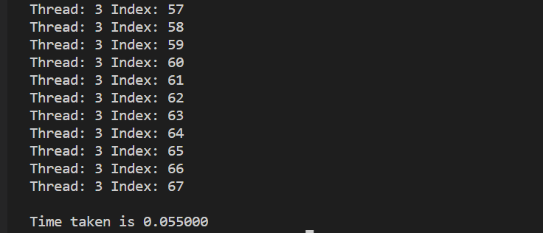

**Information:**

Execution time for sequential processing is:

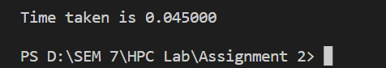

Execution time for parallel processing is:

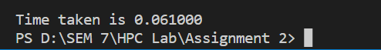

**Analysis:**

Increasing the thread count beyond the number of CPU cores can potentially reduce execution time up to a point. Beyond that point, excessive threads may introduce overhead. Changing the thread count won't directly affect execution time since it's fixed at 6 threads. However, execution time can still vary depending on hardware and workload characteristics.

|  |  |  |  |  |  |
| --- | --- | --- | --- | --- | --- |
| Threads | 1 | 2 | 4 | 8 | 16 |
| time | 0.14000 | 0.025000 | 0.040000 | 0.026000 | 0.020000 |

**Problem Statement 2: Calculation of value of Pi**

**Screenshots:**

**Calculation of value of Pi Sequential Code:**

#include <stdio.h>

#include <stdlib.h>

#include <time.h>

#define NUM_POINTS 1000000

int main() {

    srand(time(NULL));

    clock_t start_time = clock();

    int inside_circle = 0;

    for (int i = 0; i < NUM_POINTS; i++) {

        double x = (double)rand() / RAND_MAX;

        double y = (double)rand() / RAND_MAX;

        double distance = x * x + y * y;

        if (distance <= 1.0) {

            inside_circle++;

        }

    }

    double pi = 4.0 * inside_circle / NUM_POINTS;

    printf("Estimated Pi value (sequential): %lf\n", pi);

    clock_t end_time = clock();

    double execution_time = (double)(end_time - start_time) / CLOCKS_PER_SEC;

    printf("Execution time (sequential): %lf seconds\n", execution_time);

    return 0;

}

**Calculation of value of Pi Sequential Output:**

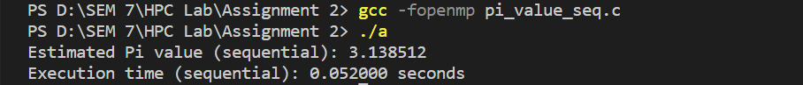

**Calculation of value of Pi Parallel Code:**

#include <stdio.h>

#include <stdlib.h>

#include <time.h>

#include <omp.h>

#define NUM_POINTS 1000000

int main() {

    srand(time(NULL));

    clock_t start_time = clock();

    int inside_circle = 0;

    #pragma omp parallel for reduction(+:inside_circle)

    for (int i = 0; i < NUM_POINTS; i++) {

        double x = (double)rand() / RAND_MAX;

        double y = (double)rand() / RAND_MAX;

        double distance = x * x + y * y;

        if (distance <= 1.0) {

            inside_circle++;

        }

    }

    double pi = 4.0 * inside_circle / NUM_POINTS;

    printf("Estimated Pi value (parallel): %lf\n", pi);

    clock_t end_time = clock();

    double execution_time = (double)(end_time - start_time) / CLOCKS_PER_SEC;

    printf("Execution time (parallel): %lf seconds\n", execution_time);

    return 0;

}

**Calculation of value of Pi Parallel Output:**

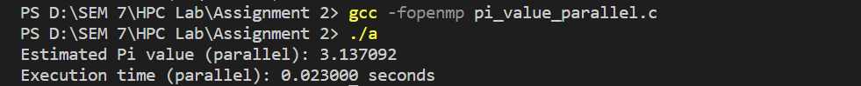

**Information:**

Execution time for sequential processing is:



Execution time for parallel processing is:



**Analysis:**

Increasing the thread count beyond the number of CPU cores can potentially reduce execution time up to a point. Beyond that point, excessive threads may introduce overhead. Changing the thread count won't directly affect execution time since it's fixed at 6 threads. However, execution time can still vary depending on hardware and workload characteristics.

|  |  |  |  |  |  |
| --- | --- | --- | --- | --- | --- |
| **THread** | **1** | **2** | **4** | **8** | **16** |
| **Time** | **0.0024** | **0.022000** | **0.016000** | **0.015000** | **0.016000** |

**Github Link:** [**https://github.com/sumitnarake/HPC/tree/main/HPC-Lab-main**](https://github.com/sumitnarake/HPC/tree/main/HPC-Lab-main)